Unit 2达标测试卷

时间：40分钟　满分：100分

　听力部分 (40分)

一、听录音，选出所听到的单词。(10分)

(　　) 1. A. father　　　　　 B. family　　　　　 C. funny

(　　) 2. A. grandfather B. grandpa C. father

(　　) 3. A. bed B. dad C. duck

(　　) 4. A. mum B. brother C. mother

(　　) 5. A. sister B. six C. great

二、听录音，按你听到的先后顺序给图片标序号。(10分)

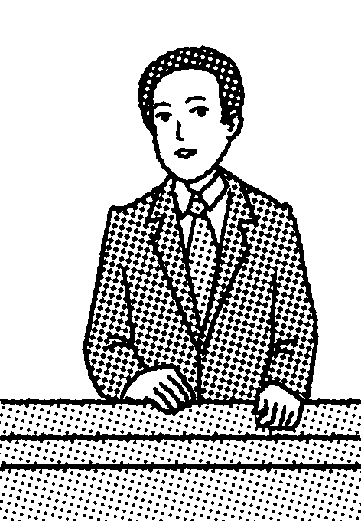　　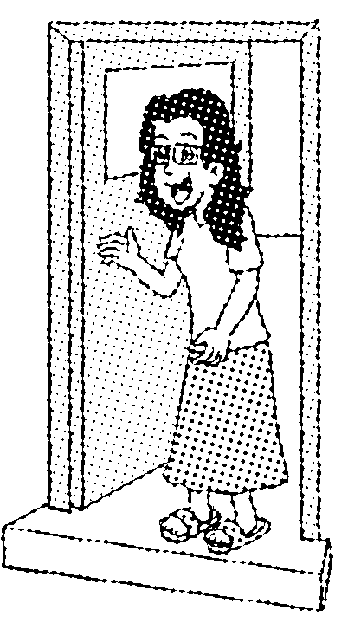　　　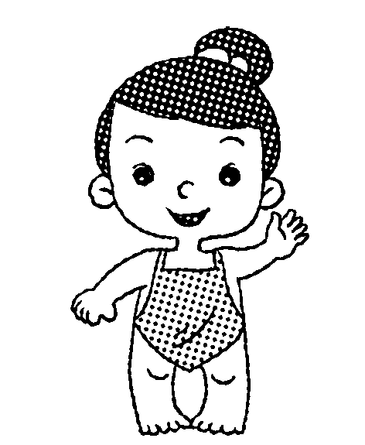　　　　　　

　(　　)　 　　(　　)　　 　 (　　)　 (　　)　　 (　　)

三、听录音，为你听到的句子选答语。(10分)

(　　) 1. A. Nice to meet you，too. 　　　　 B. I'm fine.

(　　) 2. A. Yes, he is. B. He's my father.

(　　) 3. A. She's a woman. B. She's my mother.

(　　) 4. A. Five girls. B. Ten boys.

(　　) 2. A. Yes，she is. B. Thank you!

四、听录音，判断句子与所听内容是(√)否(×)一致。(10分)

(　　) 1. —Who's that man? —Amy's grandmother.

(　　) 2. —This is my friend, Mike. —Nice to meet you.

(　　) 3. —Is he your teacher? —No, he isn't.

(　　) 4. Look! He is my brother.

(　　) 5. —Your brother is beautiful. —Thank you.

笔试部分 (60分)

五、读一读，选出每组中画线字母发音不同的一项。(5分)

(　　) 1. A. China　　　　　　　 B. man　　　　　　　 C. woman

(　　) 2. A. pencil B. seven C. tiger

(　　) 3. A. ten B. pen C. ear

(　　) 4. A. dog B. brother C. mother

(　　) 5. A. grandma B. girl C. orange

六、选出不同类的一项。(5分)

(　　) 1. A. Sarah B. Amy C. friend

(　　) 2. A. grandfather B. grandmother C. she

(　　) 3. A. leg B. ten C. seven

(　　) 4. A. teacher B. beautiful C. actress

(　　) 5. A. brother B. sister C. guess

七、根据要求写单词。(5分)

1. father(对应词)________ 2. woman(对应词)________

3. brother(对应词)________ 4. boy(对应词)________

5. friend(复数)________

八、选词填空。(5分)

grandpa　teacher　family　Who　girl

1. —________is that ________?

—She is my sister.

2. My father's father is my________.

3. Mr Jones is a good________.

4. This is my________.

九、单项选择。(5分)

(　　) 1. ________ that girl?

A. Who's　　　　　　 B. What C. How

(　　) 2. The girl ________ my friend，Chen Jie.

A. are B. is C. am

(　　) 3. —Is she your teacher?

—No, she ________.

A. isn't B. not C. is

(　　) 4. What________ your family?

A. about B. of C. to

(　　) 5. ________beautiful!

A. Who B. What C. How

十、这个小朋友正在给你介绍他的家人，请帮他连一连。(5分)

1. This is my grandfather. A. 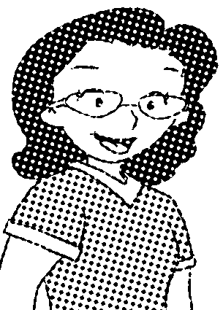

2. This is my grandmother. B. 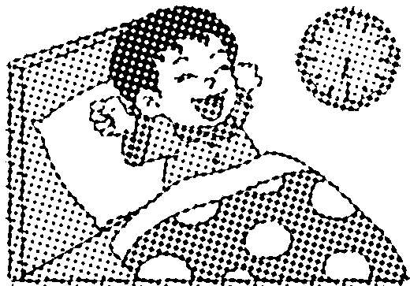

3. This is my father. C. 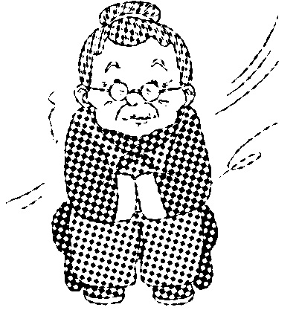

4. This is my mother. D. 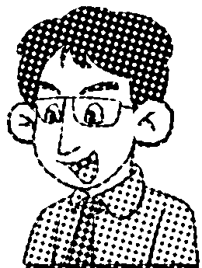

5. This is my brother. 　 E. 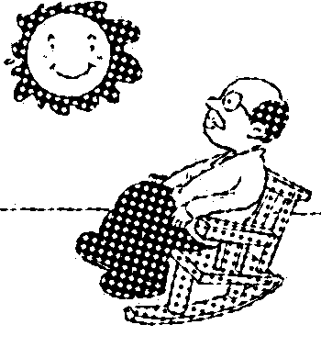

十一、情景交际。(5分)

(　　) 1. 你想把你的妹妹介绍给你的朋友Amy认识时，你应该说：

A. Amy, this is my sister. 　　　 B. She is Amy，Sister.

C. This is Amy，Sister.

(　　) 2. 第一次见到刘华爷爷，你应该说：

A. My name is Mike. B. Nice to meet you, Mr Liu.

C. How are you?

(　　) 3. 你想知道远处的男士是不是迈克的爷爷，你应该说：

A. Mike，is that your grandpa? B. Mike，is this your grandpa?

C. Mike，is that your grandma?

(　　) 4. 你想知道对方家人的情况，你应该说：

A. What about your family? B. Why are your family?

C. How are your friends?

(　　) 5. 你想让同学看你们的全家福照片时，你应该说：

A. Look at my school. B. Look, this is my father.

C. Look, this is my family.

十二、看图片，根据情景选择恰当的句子完成对话(填序号)。(10分)

1. 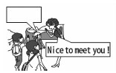　　 2. 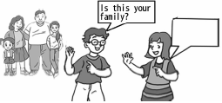

3. 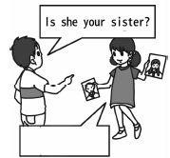 4. 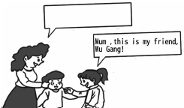

5. 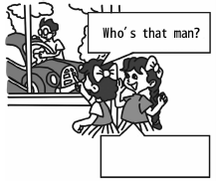

十三、依照例子，写对话。(10分)

A. He's Mike's father.

B. Hi, Wu Gang! Nice to meet you.

C. Yes, it is.

D. Nice to meet you, too.

E. No, she isn't.

例：(woman /mother)

—Who's that woman?

—She's my mother.

1. (man/ father)

__________________________________________________________________.

__________________________________________________________________.

2. (boy /brother)

__________________________________________________________________.

__________________________________________________________________.

3. (woman/ grandma)

__________________________________________________________________.

__________________________________________________________________.

4. ( man/ teacher)

__________________________________________________________________.

__________________________________________________________________.

5. (girl / Mike's sister)

__________________________________________________________________.

__________________________________________________________________.

十四、阅读短文，判断对错(对的在括号里写T，错的写F)。(5分)

Look at that photo(照片). That man is my father. He is 48. That woman is my mother. She is 45. That young(年轻的) man is my brother. He is 24. That little boy is my brother's son. He is 1. That girl is me. I'm 16. I love them. And they love me very much. That is my family. All my family help each other.

(　　) 1. That man is my father.

(　　) 2. My mother is 48.

(　　) 3. My brother is 1.

(　　) 4. I am a girl. I'm 16.

(　　) 5. There are four people in my family.

Unit 2达标测试卷

听力材料：

一、1. family　2. grandfather　3. dad 4. mother　5. sister

二、1. grandma　2. father　3. brother 4. mother　5. sister

三、1. Nice to meet you.

2. Is he your brother?

3. Who's that woman?

4. How many girls?

5. Your mother is beautiful!

四、1. —Who's that man?

—Amy's grandfather.

2. —This is my friend, Mike.

—Nice to meet you.

3. —Is he your teacher?

—Yes, he is.

4. Look! This is my brother.

5. —Your mother is beautiful.

—Thank you.

答案：

一、1. B　2. A　3. B　4. C　5. A

二、2　4　5　1　3

三、1. A　2. A　3. B　4. A　5. B

四、1. ×　2. √　3. ×　4. ×　5. ×

五、1. B　2. C　3. C　4. A　5. C

六、1. C　2. C　3. A　4. B　5. C

七、1. mother　 2. man　 3. sister　 4. girl　 5. friends

八、1. Who; girl　2. grandpa　3. teacher　4. family

九、1. A　点拨：句意：那个女孩是谁? Who谁； What什么； How如何。

2. B　点拨：girl是第三人称单数，后接is。

3. A　点拨：本句的否定回答为：“No, she isn't. ”。

4. A　点拨：What about your family？你的家庭呢？

5. C

十、1—E　2—C　3—D　4—A　5—B

十一、1. A　2. B　3. A　4. A　5. C

十二、1. D　2. C　3. E　4. B　5. A

十三、1. —Who's that man?

—He's my father.

2. —Who's that boy?

—He's my brother.

3. —Who's that woman?

—She's my grandma.

4. —Who's that man?

—He's my teacher.

5. —Who's that girl?

—She's Mike's sister.

十四、1. T　2. F　3. F　4. T　5. F